Now you become a Owner of your own Sand Empire! Here is where your Journey will Start!
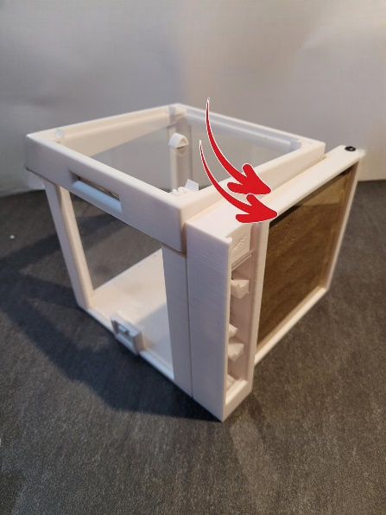
- Inside your packets you will find a few Bags of Sand, This sand is allready mixed with Loam Sand and Regular Sand. You will also find a Pipet this you will need too Moistering the Sand Layer by Layer. Arround 1 Cm ( 0,40 Inches )

- The First thing we have to do is INSERT the 2
Acrylic Glasses (Where the 2 Red Arrows are, Each
on 1 Side. Gently Press it into the slots where the Acrylic will be in. Dont forget too remove the plastic what is for protection on the Acrylic glass. Or you Won’t see your colony digging.

- After we have Insert the Acrylic! We can start filling it with the Mixed Sand. Put all your sand in a small bin, get a Spoon and Gently let some Sand fall in between the 2 Acrylic, untill you have 1 CM ( 0,40 Inches ) get your Pipet and water and use the Pipet too moistering the sand, DONT use too much water, its just to get a little bit WET. Repeat this each layer, 1cm sand – moistering - Repeat. Untill its completely full.
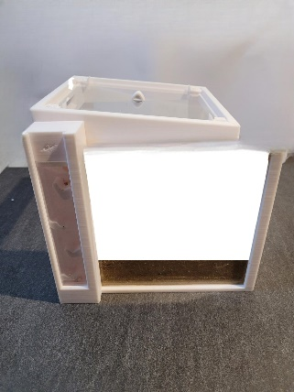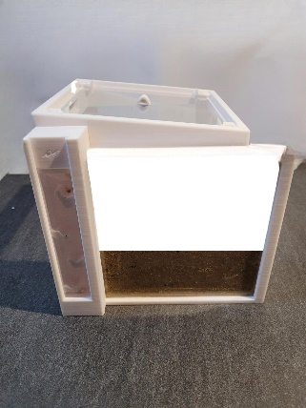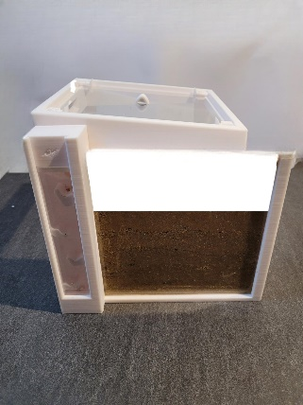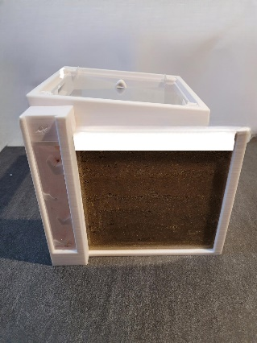
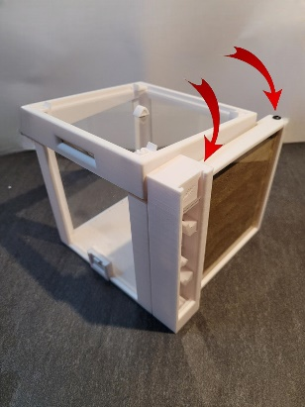
- Too finish it, place your last piece with the screw hole inside. Gently press the Side with NO SCREW HOLE. Inside the 3d printed tower, when it fully inside you can press it on the acrylic and you and Screw it all on it. from BOTH sides. 1 in the tower 1 in the pillar.

